**2013 Save Your Breath Events**

**SPONSORSHIP OPPORTUNITIES**

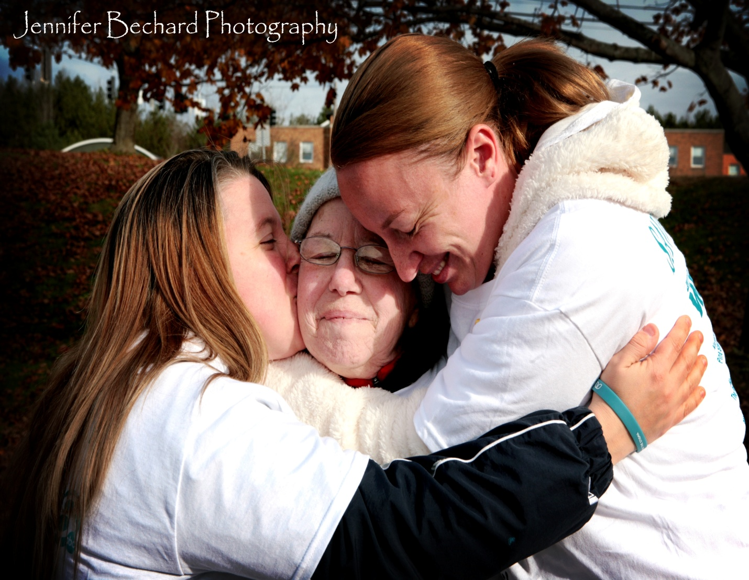

All Proceeds Benefit: **Free ME from Lung Cancer - research, education and community support**

**WHO WE ARE**

**Free ME from Lung Cancer** is a non-profit organization. We are dedicated to raising money for lung cancer research, education, and community support. We are committed to making lung cancer a national priority.

**OUR MISSION**

To decrease the suffering caused by a diagnosis of lung cancer by raising much needed money for lung cancer research, education, and community support.

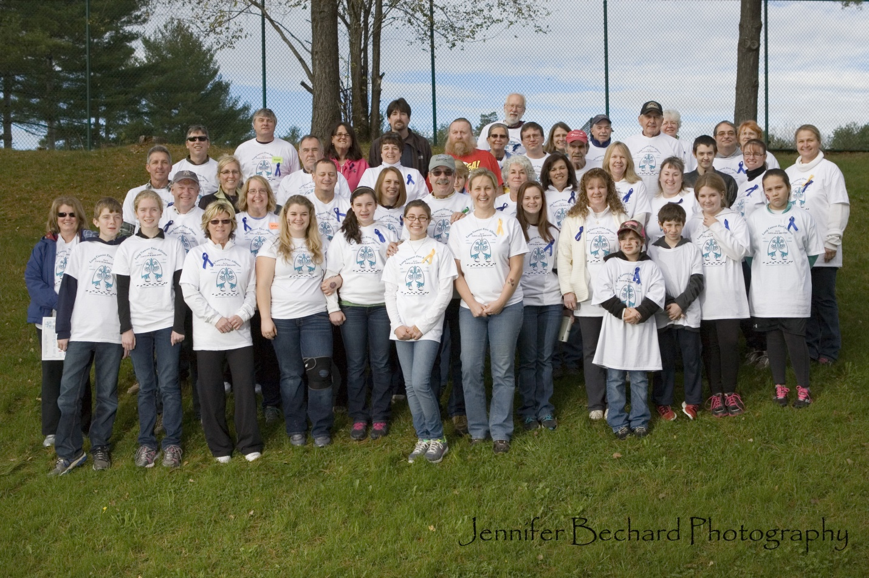

**ABOUT SAVE YOUR BREATH EVENT**

Our **Save Your Breath** fundraiser will connect families, friends, neighbors and coworkers creating a community of support and empowerment. It will help lung cancer patients, families and caregivers connect with others facing this disease to provide hope and inspiration.

**DID YOU KNOW?**

Lung cancer is the number one cause of death from cancer. It takes more lives than breast, prostate, and colon cancer combined. Every day more than 440 people lose their battle to lung cancer. This is equal to a jumbo jetliner crashing every signal day. Sadly, one in fourteen Americans will be diagnosed with lung cancer in their lifetime. Lung cancer receives less than 5% of federal cancer research funding but accounts for more than 28% of

cancer deaths. There is no effective early diagnostic testing for lung cancer. Only 16% of all those diagnosed with lung cancer will survive more than 5 years. The 5 year survival rate will improve by 52% if lung cancer is caught in its early stage before it has spread. ***Lung cancer statistics from the American Cancer Society’s Cancer Facts and Figures 2012 and National Cancer Institute SEER data 2011.***

**WHY SPONSOR THE SAVE YOUR BREATH EVENTS?**

Sponsorship levels range from $250 to $5000, but we are committed to finding the right package for you and will create a package with benefits that will best fit your needs. Depending on the sponsorship level package chosen will provide you with corporate or brand visibility while making an impact on the lives of those touched by lung cancer. Your generous gift will help fund research; provide education and community support to those affected by lung cancer and their caregivers. Your gift today can help save lives tomorrow.

**HOW YOUR MONEY WILL BE SPENT**

For every dollar donated 55 cents will go to research, 10 cents will go to education, 29 cents will go to community support and 6 cents will go to administrative expenses. How can we keep our expenses so low? **Free ME from Lung Cancer** is an all-volunteer organization.

**SPONSORSHIP OPPORTUNITIES**

**DIAMOND SPONSORSHIP: $5,000**

* Promotion of the sponsor as a Diamond Sponsor in press releases and at the event
* Sponsor’s logo on the welcome banner on event day
* Sponsor’s logo included on printed event materials
* 6 complimentary registrations for the event
* Sponsor’s logo on the back of event t-shirts*
* Sponsor’s promotional items in event goody bags to be provided by the sponsor
* Exhibit space on event day
* Sponsor’s logo included on event webpage

**PLATINUM SPONSOR $2,500**

* Sponsor’s logo on welcome banner on event day
* 4 complimentary registrations for the event
* Sponsor’s logo on the back of event t-shirts*
* Inclusion of sponsor’s promotional items in event goody bags to be provided by the sponsor
* Exhibit space on event day
* Sponsor’s logo included on event webpage

**GOLD SPONSOR $1,000**

* Sponsor’s logo on welcome banner on event day
* 2complimentary registrations for the event
* Sponsor’s logo on the back of event t-shirt*
* Exhibit space on event day
* Sponsor’s logo included on event webpage

**SILVER SPONSOR $500**

* Sponsor’s name in text only on event brochures*
* 1 complimentary registration for the event
* Sponsor’s logo on the back of event t-shirts*
* Sponsor’s logo included on event webpage

**BRONZE SPONSOR $250**

* Sponsor’s logo on the back of event t-shirt*
* Sponsor’s logo included on event webpage

**IN-KIND SPONSOR**

* Sponsor’s name in text only on the event t-shirts for contributions valued at $100.00 or more*
* Sponsor’s logo included on event webpage

**MEDIA SPONSOR**

* Sponsor’s logo on welcome banner on event day
* Sponsor’s logo on the back of event t-shirts*
* Sponsor’s logo included on printed event materials including advertising and event brochures
* Sponsor’s logo included on event webpage

**\*DEPENDENT ON SPONSORSHIP PLEDGE COMMITMENT DATE IN RELATION TO PRINTING DEADLINE**

**2013 Save Your Breath Events**

Thank you for your very generous support to the **Save Your Breath – EVENT** to benefit the **Free ME from Lung Cancer’s** mission. Your support today will help save lives tomorrow.

Sponsor – Company Name (please write it as it should appear on our promotional materials)

Contact Name and Title: ________________________________________________________

Mailing Address: ______________________________________________________________

City: ________________________________________ State: _______________ Zip: _______

Phone Number: _______________________________ Fax Number: _____________________

Email: _______________________________________________________________________

Website: _____________________________________________________________________

Sponsorship Level:

_­­__$5,000 Diamond ___$2,500 Platinum ___ $1,000 Gold ___$500 Silver ___ $250 Bronze ___ In-Kind donation

Please describe the in-kind item or service donated, the quantity donated and the fair market value of the item or service.

_____________________________________________________________________________________________

_____________________________________________________________________________________________

NOTE: Please email your logo in EPS format. If your logo is not available in EPS format please send a high resolution JPG file. Logos must be received no later than September 30th. Email logo to Karen Jones at [poetress68@hotmail.com](mailto:poetress68@hotmail.com)

TOTAL CONTRIBUTION ENCLOSED: $______________________

____Full Payment Enclosed ____Please Send Invoice ____ Charge My Credit Card

Please make checks payable to: **Free ME from Lung Cancer** (include **Save Your Breath** in the memo section)

Credit Card ___ Visa ___ MasterCard ___ AMEX ___ Discover

Name or Card: ____________________________________________________________________________________

Card Number: ______________________________ Code _________ Expiration Date: ______________

Phone Number: ______________________________________ Fax Number: _____________________

Mail completed form and payment to:

**Free ME From Lung Cancer**

Deb Violette, President

176 Leavitt Road

Augusta, Maine 04330

Signature: ________________________________Date: _________________

Once we receive the form we will contact you to confirm and implement your sponsorship.

**For more information contact** [**Deb@freemefromlungcancer.org**](mailto:Deb@freemefromlungcancer.org) **or 207-622-6155**

**Free ME from Lung Cancer has applied for their 501(c) (3) nonprofit organization status (EIN 36-4734024). They are currently recognized in the State of Maine as a domestic nonprofit organization. Sponsorships are non-refundable.**